# VISVESVARAYA TECHNOLOGICAL UNIVERSITY

JNANASANGAMA, BELAGAVI-590018

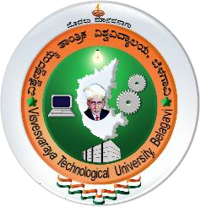

**REPORT ON AICTE ACTIVITY POINTS**

|  |  |
| --- | --- |
| Name & USN of the student | **NISHANT PATIL (1JS19ME051)** |
| Department, Semester & Section | **MECHANICAL ENGINEERING, 8th Sem & ‘B’ Sec** |
| Entry to Program | **Regular** |
| Activity Points | **50** |
| Title (s) of Activity undertaken | * Resource utilization and school cleaning * HAM radio communication   and career guidance   * Tourism promotion and survey about tourism places |
| Place (s) of Activity | 1. Khazimakan higher primary school 2. Khazimakan higher primary school and Hosakote village 3. Dodda Hosakote lake and Hosakote taluk |
| Date (s) of activity | 1. 09/01/2023 to 22/01/2023 2. 30/01/2023 to 12/02/2023 3. 20/02/2023 to 26/02/2023 |
| Number of Weeks or Hours involved | **5 WEEKS AND 200 HOURS** |
| Name of the Mentor | **Ms. D N ROOPA** |

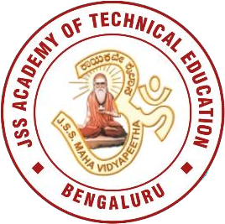

JSS ACADEMY OF TECHNICAL EDUCATION

JSS Campus, Dr.Vishnuvardan Road, Srinivaspura, Bengaluru, Karnataka 560060

2022-2023

JSS ACADEMY OF TECHNICAL EDUCATION, BENGALURU

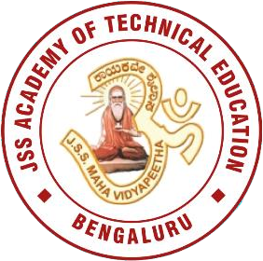

# DEPARTMENT OF MECHANICAL ENGINEERING

**CERTIFICATE**

This is to certify that **Mr. NISHANT PATIL** bearing USN **1JS19ME051** is a Bonafede student and has actively involved in bringing awareness / trained / implemented / demonstrated / facilitated and successfully completed the activity undertaken as stated above. This assignment is a part of AICTE Activity Points Program and for the partial fulfilment for the award of degree of Bachelor of Engineering in Mechanical Engineering.

**Activity Points Earned: 50**

**Name and Signature of the Mentor: Ms. D N ROOPA**

## Name and Signature of the NSS / NCC / Saansad Adarsh Gram Yojana (SAGY) Coordinator: Dr. GIRISH.N

**Name and Signature of the HOD: DR. B V RAGHAVENDRA**

## Name and Signature of the Principal: DR. BHIMASEN SORAGAON

JSS MAHAVIDYAPEETHA

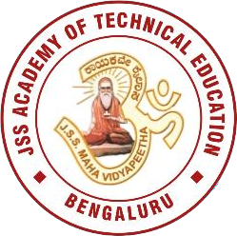

JSS ACADEMY OF TECHNICAL EDUCATION, BENGALURU

Affiliated to Visvesvaraya Technological University, Belagavi, Karnataka, INDIA Approved by All India Council for Technical Education, New Delhi

UG programs accredited by NBA: ECE, CSE, ISE, CIVIL, MECHANICAL, IEM, E&IE

# Evaluation Sheet for AICTE Activity Points Program (Academic Year: 2022-2023)

## Name of the student: PRITHVIRAJ PATIL USN: 1JS19CS125 Department: COMPUTER SCIENCE AND ENGINEERING

## SEM/SEC: 8th sem , ‘B’ sec

|  |  |  |  |  |  |  |  |
| --- | --- | --- | --- | --- | --- | --- | --- |
| **SL.**  **NO.** | **Title of the Activity** | **Place of the Activity** | **Date of the Activity** | | **No. of Hours** | **Type of Documentary Evidence** | **Points Earned** |
| **From** | **To** |
| **1.** | Resource utilization and school cleaning | Khazimakan higher  primary school | 09/01/2023 | 22/01/2023 | 80 | Certificate |  |
| **2.** | HAM radio communication and career guidance | Khazimakan higher primary school and Hosakote village. | 30/01/2023 | 12/02/2023 | 80 | Certificate |  |
| **3.** | Tourism promotion and survey about tourism places | Dodda Hosakote lake  and Hosakote taluk | 20/02/2023 | 26/02/2023 | 40 | Certificate |  |

**Note:**

* For the regular students admitted in 2018-19 & 2019-20 and for the lateral entry students admitted in 2019-20 & 2020-21 shall earn 100 & 75 points respectively for the award of degree through AICTE Activity Point Program.
* As per AICTE guidelines, two weeks (approx. 80-90 hours) of activities by a student account for 20 points. A similar proportion may be used for awarding the points.
* For evaluation of points such as certificate, photographs, brief report on the activity shall be given weightage.

**Signature of the Mentor**

# * CONTENT: -

## ACTIVITY -1

**Resource utilization and school cleaning**

## ACTIVITY- 2

## HAM radio communication and career guidance

## ACTIVITY -3

**Tourism promotion and survey about tourism places**

## ACTIVITY -1

**Resource utilization and school cleaning**

## ABSTRACT:

## Swachh Bharat

## Mahatma Gandhi rightly said, “Sanitation is more important than independence”. Swachh Bharat-mission was launched by the Government of India to solve the problems of sanitation and waste management in India by ensuring hygiene across the country. The main aim of the project is to create sanitation facilities for all.

## ABOUT MY WORK

It was a great experience and my privilege to clean the under privileged government school in Hosakote talk the school was not clean and all the garbage was scattered all around the school premises the dry waste and wet waste was not managed properly the school there was no hygrine maintained in the school there was water clogged on terrace and all the plant waste was laying all around classrooms were full dusty and not clean were me and some of my friend took permission to clean the school and was supported by the Marshel NGO team.

#### **OUTCOME:**

By this activity, we encourage all to bring about necessary regulatory and policy changes to facilitate the scientific processing of waste and to focus on bringing about behaviors change among citizens and encouraging them to segregate waste at source.

#### **CONCLUSION OF THE ACTIVITY:**

1. This activity helped us to clean the school and give a supportive hand to school student to maintain the hygiene and their cleanliness which helps them to maintain their health and hygiene which is one of the most important aspects in a student life.
2. Marshel is a superior NGO organization plays unique role in developing hosakote Rural area in terms of education.
3. We understand the significant role as citizen of India for supporting SWATCHH BHARATH ABHIYAN.

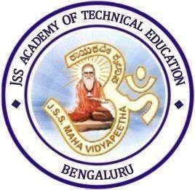

**Gallery of photos**

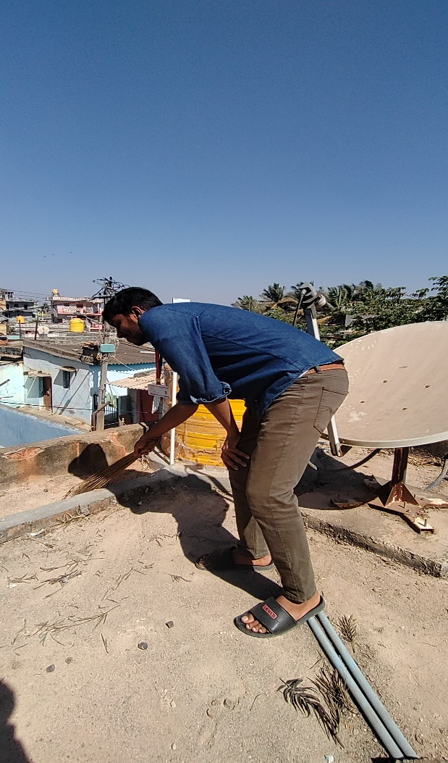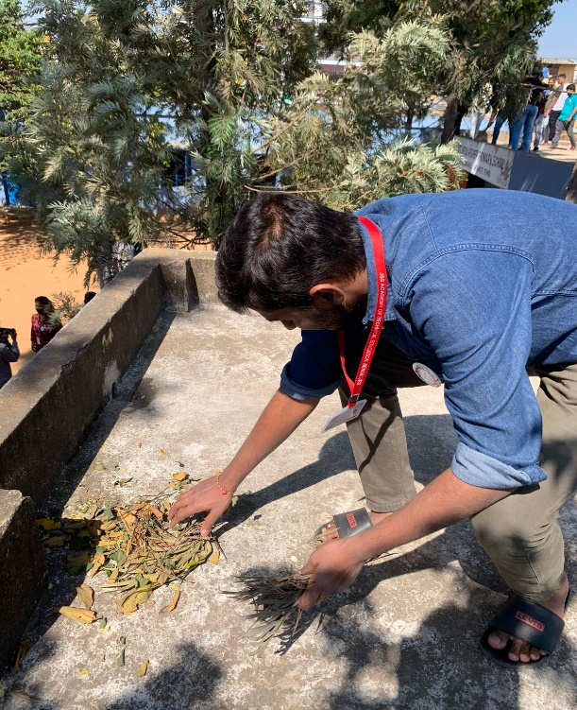

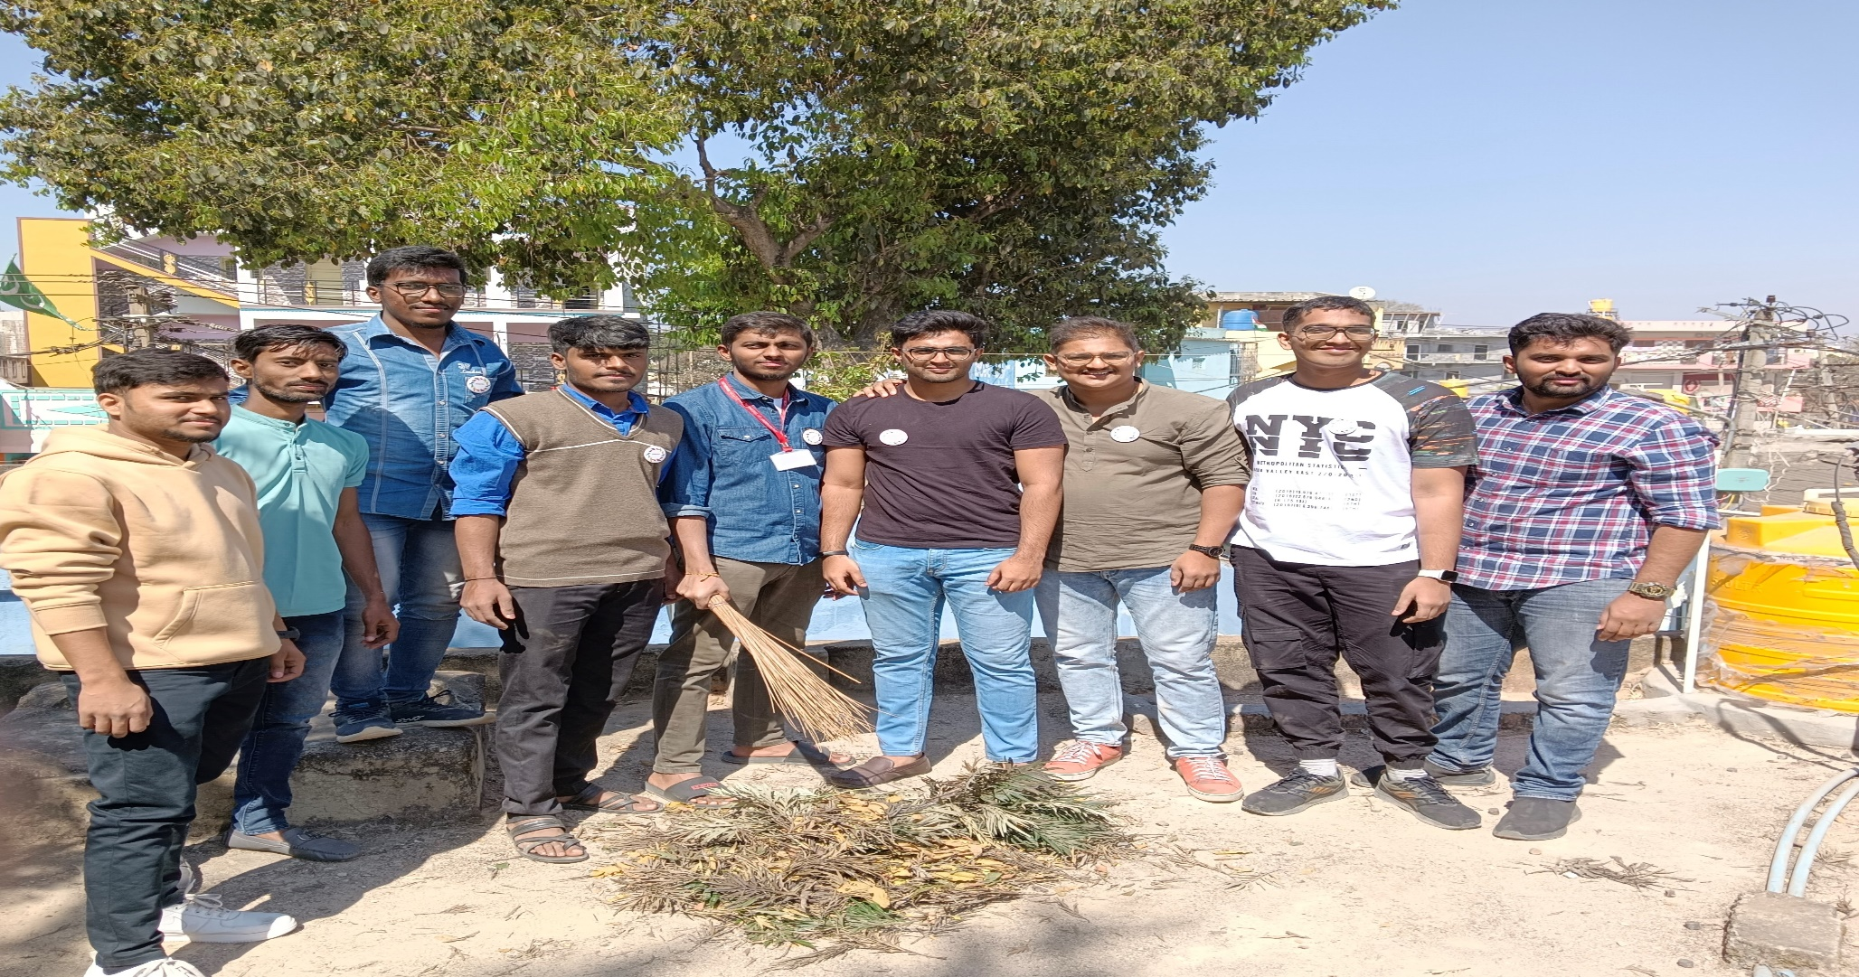

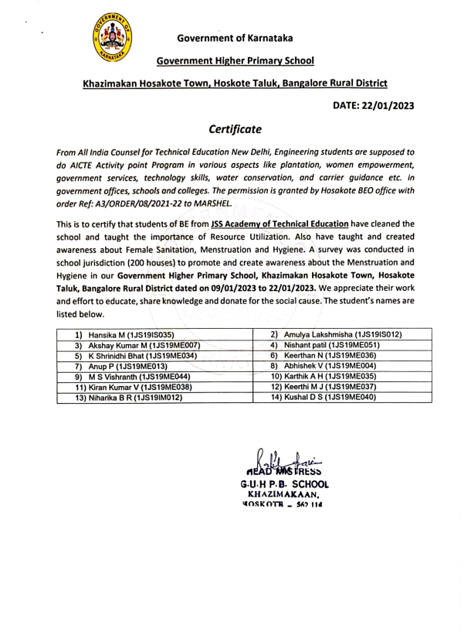

**ACTIVITY-2a**

HAM radio communication and career guidance

**ABSTRACT**

**ABOUT TECHNICAL EDUCATION**

A career and technology-based education will help your child to be more than just an average student. Career and technology education can give your child what’s needed to succeed for life: technical skills, academic skills and employability skills.

**ABOUT MY WORK**

It was a great experience to share my knowledge about HAM Radio communication and create awareness on how they work. I taught government school students about the HAM Radio communication and technology and where it is used, how it is used and how it works and mainly it is used in military police departments.

**How does it work?**

Amateur radio operators - and they can be doctors, students, kids, politicians, truck drivers, movie stars, missionaries and what you - share a basic knowledge of radio technology and operating principles, and pass an examination for a license issued by the Federal Communications Commission (FCC). The license allows ham radio operators to operate on radio frequencies allocated by the FCC for use; these frequencies are also known as the “Amateur Bands.” Be it through Morse Code on an old brass telegraph key, voice communication on a hand-held radio or computerized messages transmitted via satellite, all hams use radio to reach out to the world.

Hams can operate from just above the AM broadcast band to the microwave region, in the gigahertz range. Many ham bands are found in the frequency range that goes from above the AM radio band (1.6 MHz) to just above the citizens band (27 MHz). During daylight, 15 to 27 MHz is said to be a good band for long-distance communications. At night, the ideal band for is 1.6 to 15 MHz These bands are often referred to historically as short-wave bands (representing short-wave radio). Unlike frequencies used by FM radio stations and TV stations, which are line-of-sight and therefore limited to 40 or 50 miles, short-waves bounce off the ionosphere from the transmitter to the receiver’s antenna. The higher the frequency is, the shorter the wavelength. Some ham radio operators use the very dependable Morse code, while others rely on voice. Morse code signals (beeps) often get through when voice transmissions cannot.

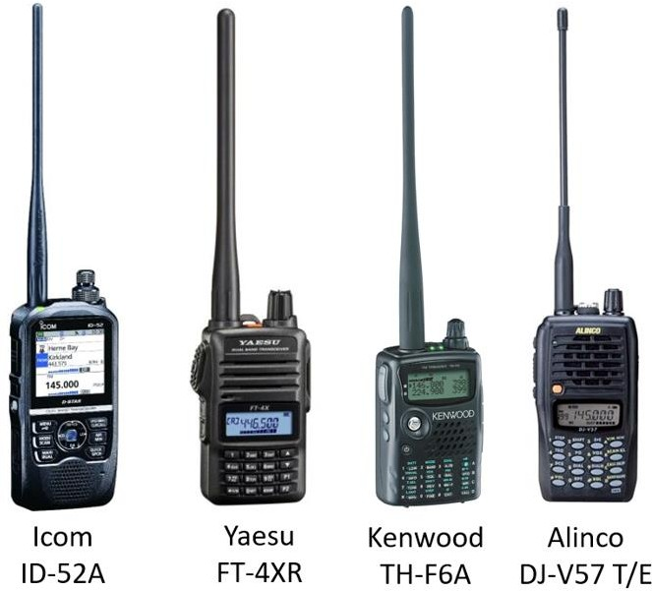

Fig: Different types of ham radios

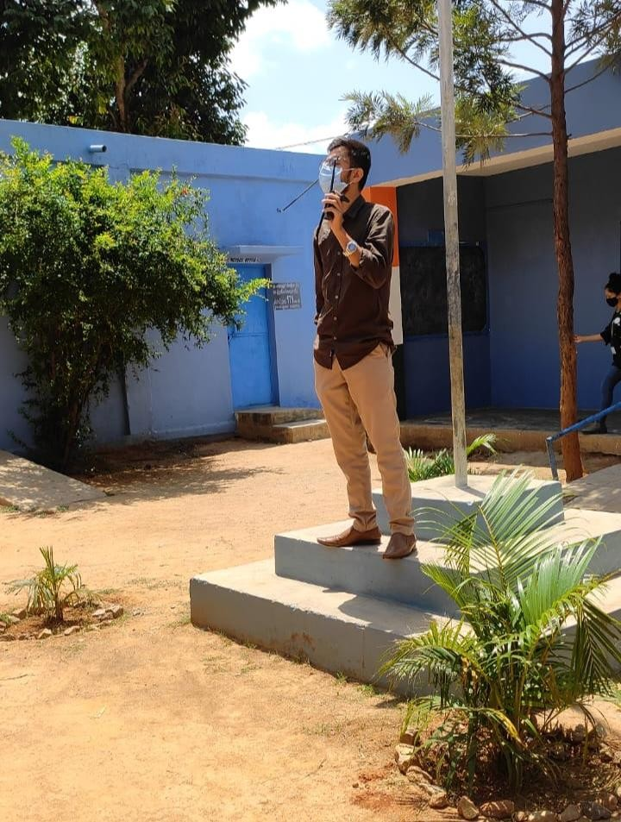

Fig: Ruman Sait U (President) explaining about HAM radio

**OUTCOME:**

Regardless of whether students are headed for college or the workforce, this type of education will help them prepare for the future. In fact, this type of technical seminar will help the under privileged to gain more knowledge about the ham radio communication system where it is used and how it works. The government school students were very enthusiastic and eager and were motivated to learn about the technology.

1. A ham radio license allows you to communicate over long distances without the internet or cell towers.
2. Cell phones and the internet rely on a massive network of cables and giant data centers.
3. can use your amateur radio license to volunteer and assist during an emergency.
4. Software Infrastructure: communication can fail due to hacking, bugs, and other software failures.
5. Learn a new skill to add to your resume.

**CONCLUSION OF THE ACTIVITY:**

This enables communication across a city, region, country, continent, the world, or even into space. In many countries, amateur radio operators may also send, receive, or relay radio communications between computers or transceivers connected to secure virtual private networks on the Internet.

**ACTIVITY-2b**

**ABOUT CAREER GUIDANCE AND IMPORTANCE OF EDUCATION**

Career guidance is a process that helps individuals identify and explore career options, make informed decisions about their future, and develop strategies to achieve their goals. It can be helpful at any stage of life, but it is especially beneficial for young people who are just starting out in their careers.

**ABOUT MY WORK**

It was interesting to share my knowledge about the career guidance and importance of education in a student life and we were taking a survey about the children’s those who are studying and their future plans. We were allowed to spread the knowledge and importance of education to all the people around the hosakote town.

**OUTCOME**

By this activity, we encourage all to bring about necessary regulatory and policy changes to facilitate the spread the scientific knowledge about career guidance and importance of education to the child which helps in motivating them to join schools and colleges. it also helps to bring change in the Indian economy by creating the next CEO and entrepreneur.

**CONCLUSION**

1. By doing this activity we were able to spread knowledge about education and career guidance to the kids who were studying in government school.
2. Also, we spread the knowledge about the education of a child to their parents which motivated them to send them to school and colleges.

**Gallery of photos**

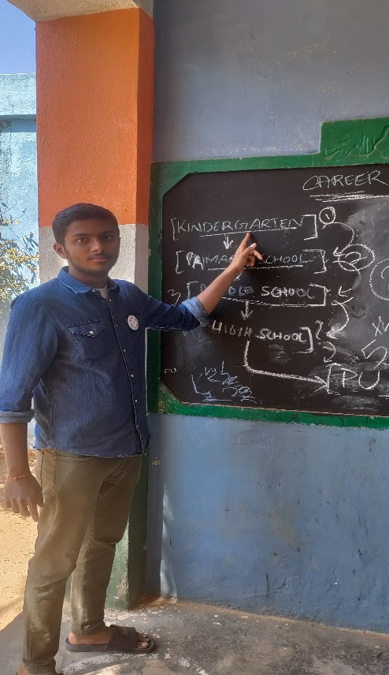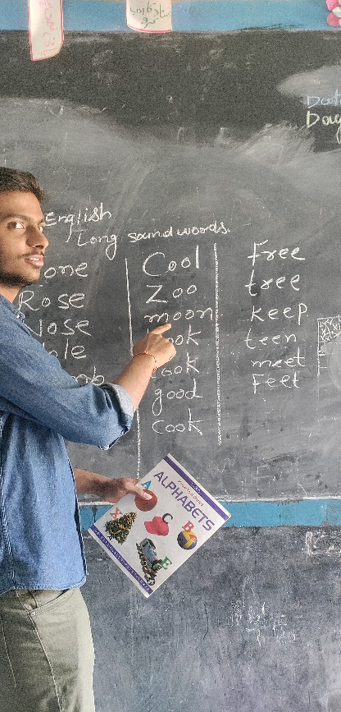

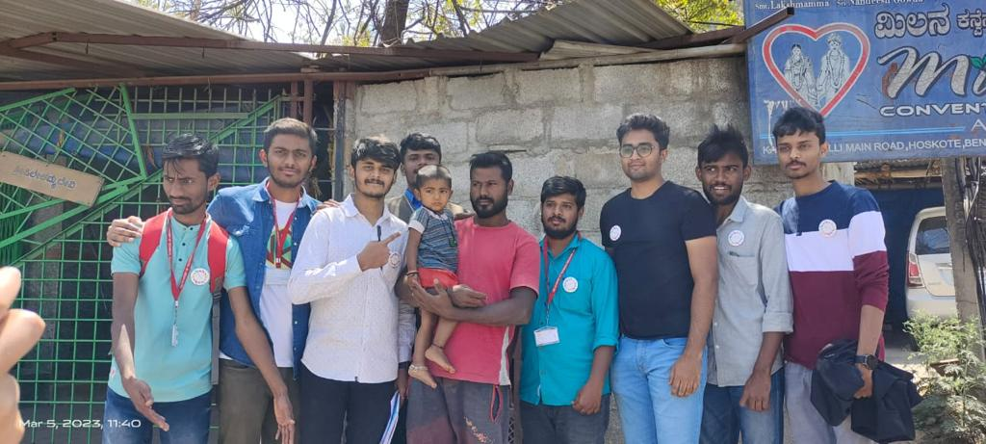

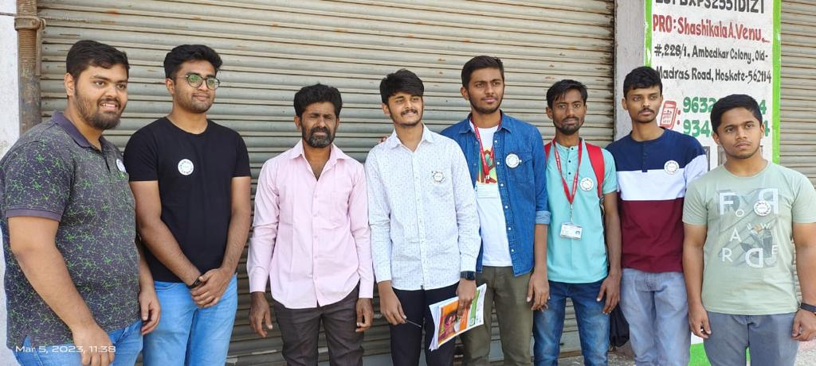

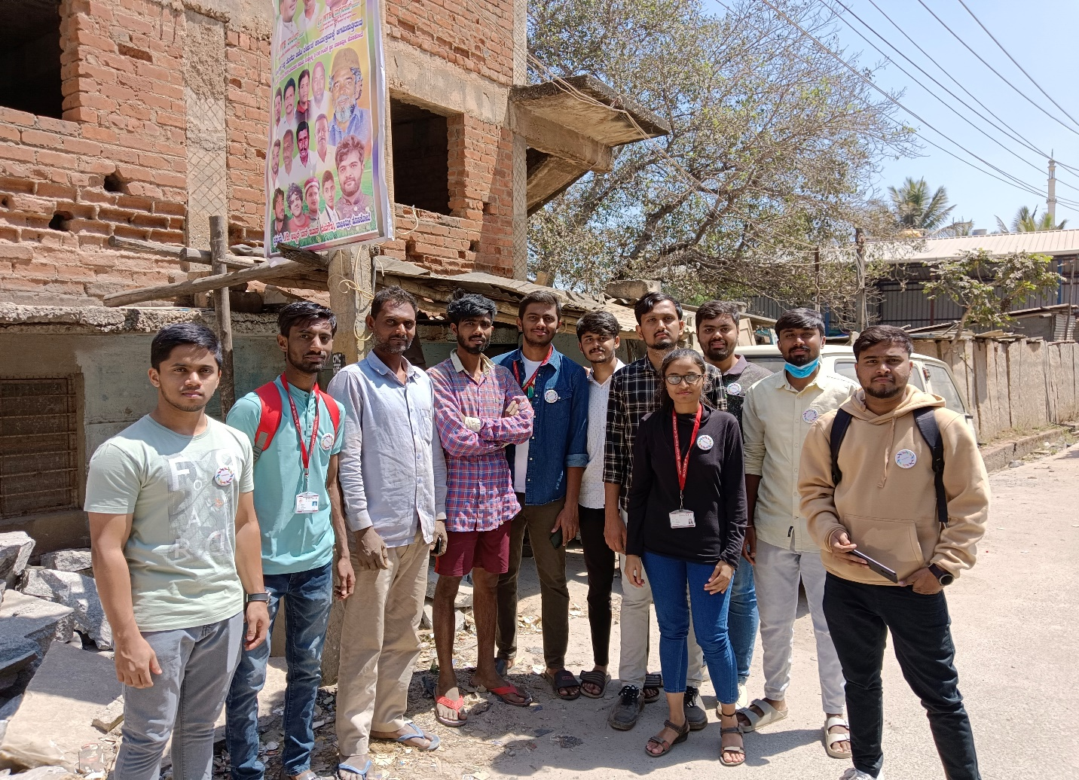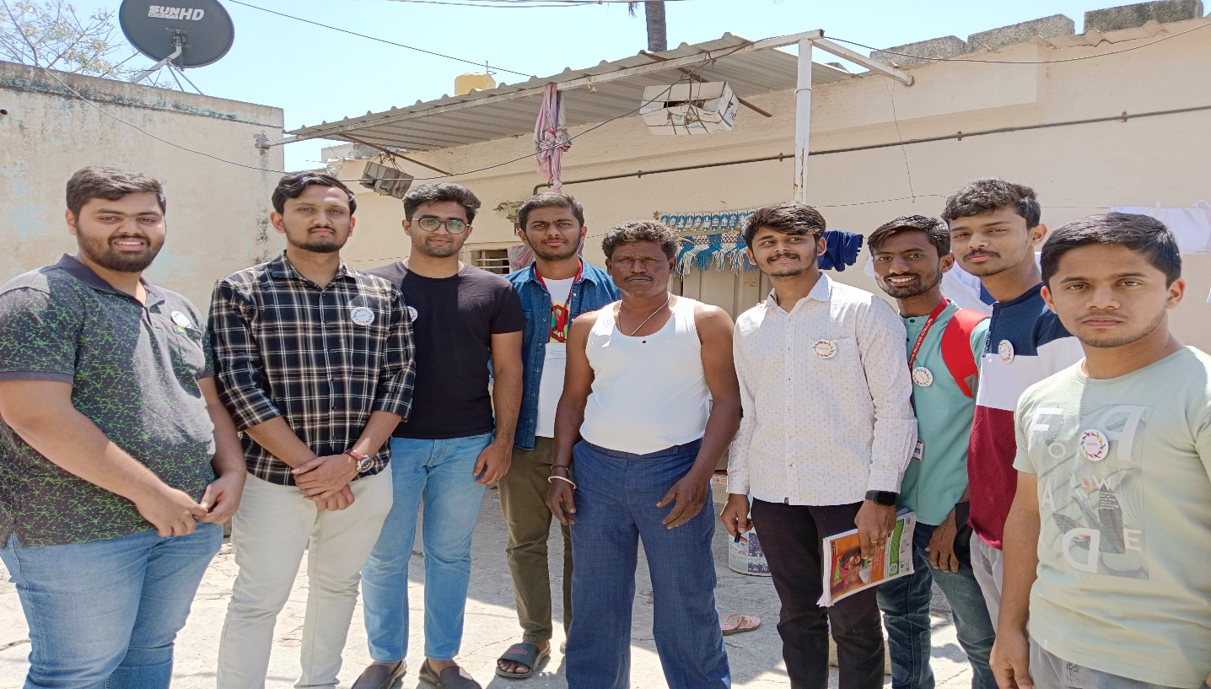

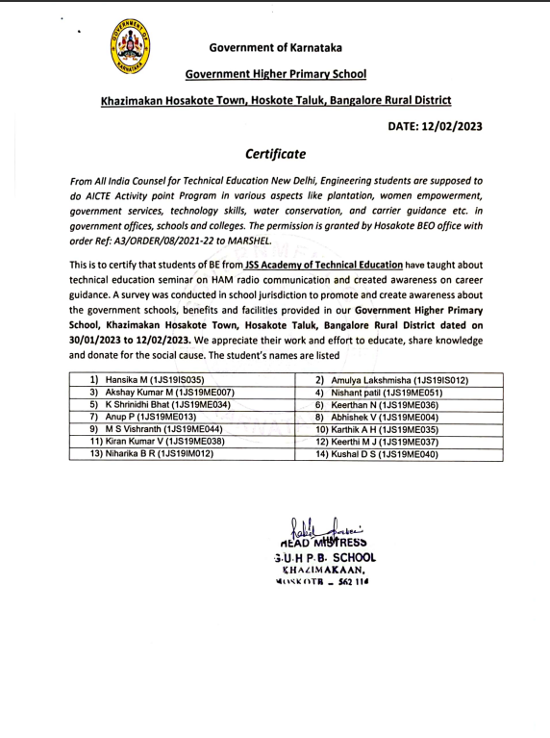

**ACTIVITY- 3**

**ABOUT TOURISM PROMOTION:**

Tourism promotion means Trying to encourage the actual and potential customers to travel a destination through the spreading of information. Promotion is one of the most effective marketing mix elements used in marketing a tourist.

About Hosakote:

Hosakote is a taluk in Bangalore Rural District. Headquartered at the Hosakote town, it consists of five hoblis - Anugondanahalli, Jadigenahalli, Kasaba, Nandagudi and Sulibele. Agriculture, apiculture and horticulture are primary occupations of people here, although the industrialization in the recent times in Hosakote and places around has thrown up new opportunities for the people. Hosakote is the largest taluk in Karnataka having 333 villages.

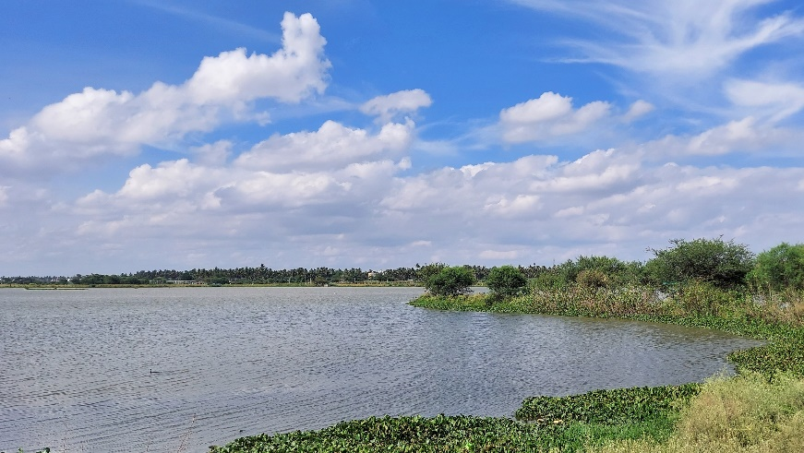

Hosakote lake

Hosakote town is the headquarters of the Hosakote Taluk, and lies at the intersection of NH-4 and NH-207 and as such is a busy town with both resident and floating population. Hosakote has a medical college and research institute known as MVJ Medical College & Research Centre.

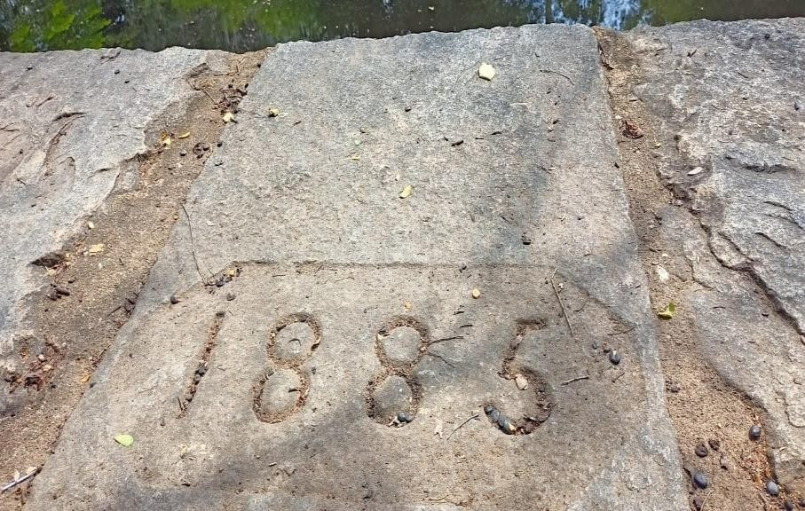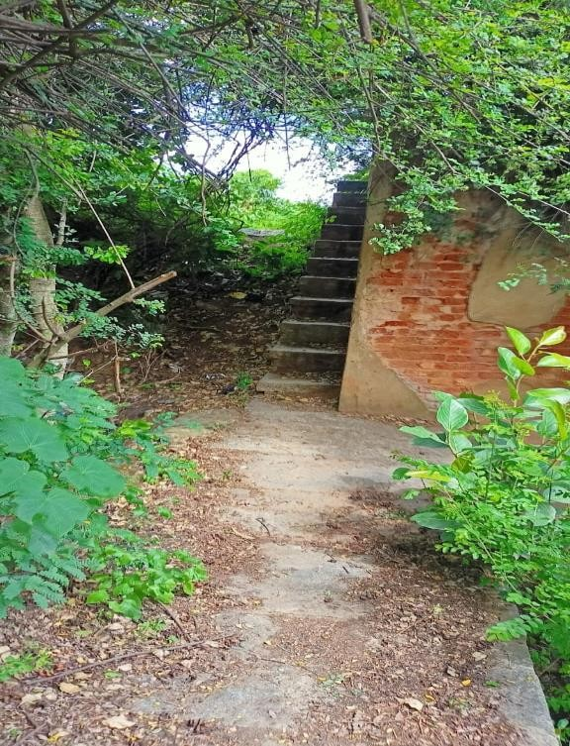

* Tippu Sultan Ancient secret route (lake to Hosakote Town) 100m length, 2m wide
* 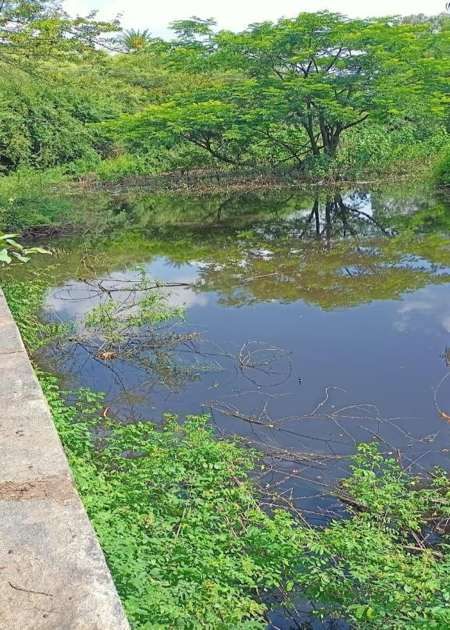Stone work Constructed – 1885

**(Small lake beside Tippu Sultan route) (Length of route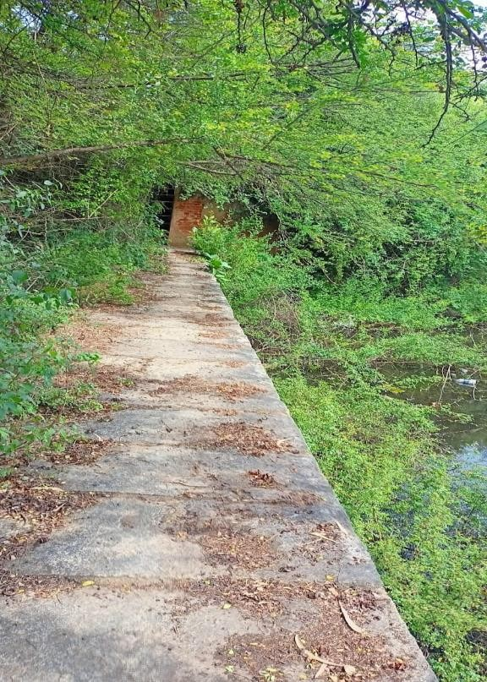)**

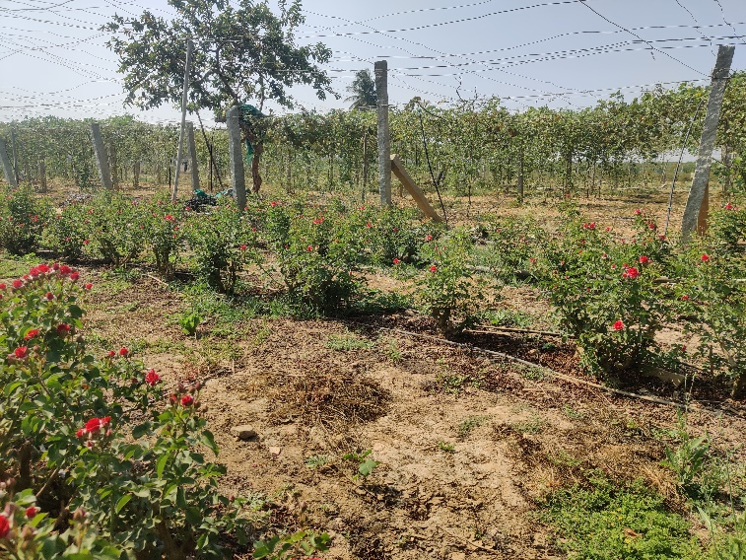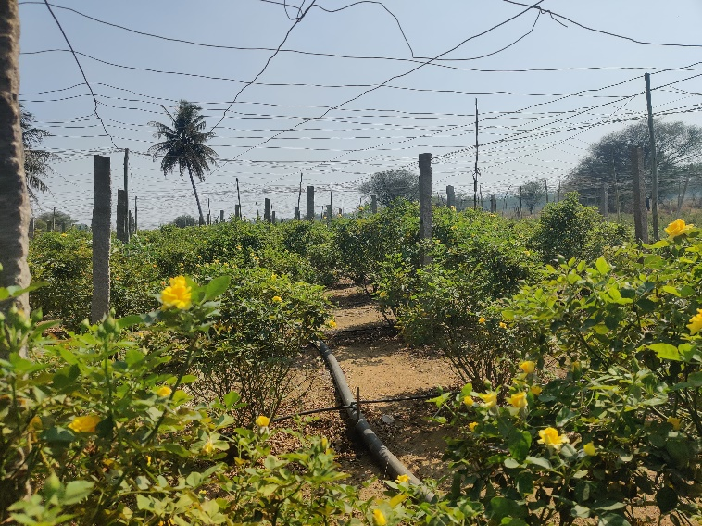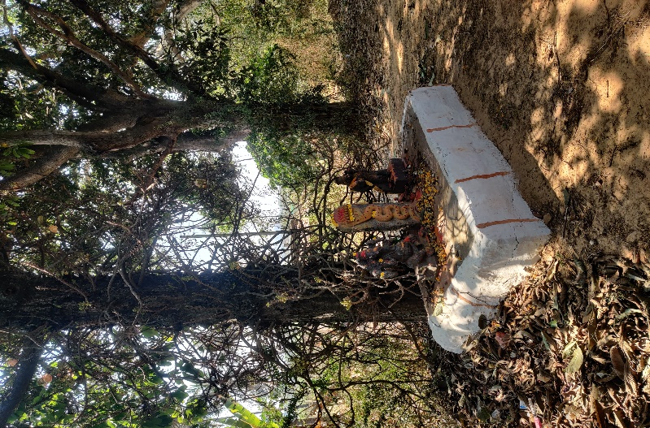 **Gallery From Lake Site**

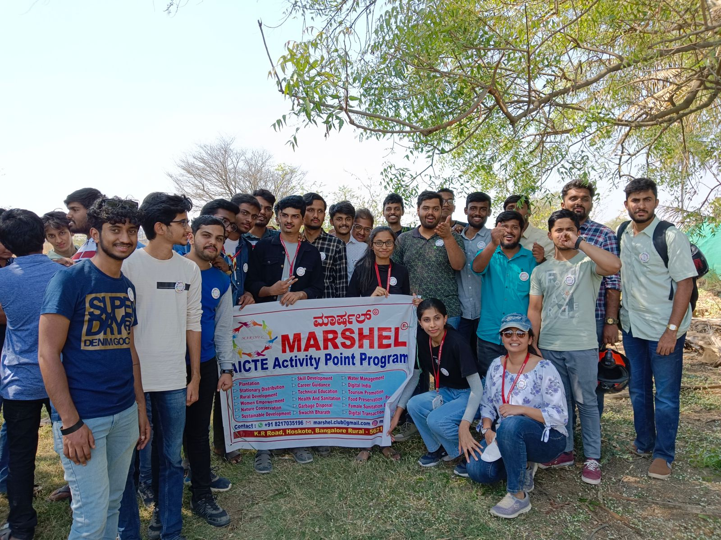

**OUTCOME:**

India is very diversified country in term of foreign invaders, rulers, etc. some special monuments, heritage place in India still in abandon state. So, its responsible for every citizen of India to promote and bring the government attention about heritage sites in India.

**CONCLUSION OF THE ACTIVITY:**

1. To promote Hosakote Rural area in order, bring the Development in Karnataka tourism sector.
2. To educate the people about epic place in Hosakote and explore History.
3. To understand solution for the Abandoned ancient heritage place. To analyze financial source for abandoned ancient heritage in India.

